

I am CG Venkatesh Raju, a passionate technologist with deep expertise in Embedded Systems and Networking, complemented by a strong enthusiasm for Artificial Intelligence and Machine Learning engineering

Restructuring it as follows;

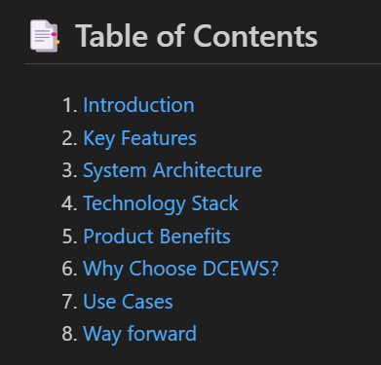

Introduction 🡺

As network processing power increases, maintaining optimal equipment temperatures has become more challenging due to higher processor densities and rising heat levels. Excessive heat can lead to equipment failure and costly downtime, making efficient cooling systems critical. Since nearly all power consumed by processors is converted to heat, data centers must effectively deliver cold air to equipment intakes and remove hot exhaust to ensure continuous operation and network availability.

Effective power, cooling, and airflow management are essential to prevent data center equipment failure and ensure reliable operation. Since nearly all incoming power converts to heat, maintaining temperatures below 80˚ to 85˚F is critical to avoid overheating. Exceeding this range triggers thermal protection, reducing processing power or shutting down equipment to prevent damage. Prolonged exposure to elevated temperatures can decrease reliability and shorten equipment lifespan, emphasizing the importance of efficient thermal management.

The increasing number of data centers and the high heat density of IT equipment have made energy-efficient thermal management a critical research focus. Localized hybrid air-water cooling offers a targeted solution to address varying heat dissipation levels across racks, unlike traditional air cooling, which often requires over-provisioning. In a closed hybrid air-water cooled server cabinet, heat is removed through a self-contained system, independent of room-level cooling. This study experimentally characterizes a hybrid-cooled enclosed cabinet and its internal components in steady-state conditions. A cabinet-level model was developed to simulate various operational scenarios, including air leakage effects. Additionally, the impact of cooling system failures on IT performance was analyzed, and the time taken for IT equipment to exceed standard temperature thresholds under failure conditions was compared.

Energy-efficient cooling is essential for modern data centers due to increasing heat loads. A hybrid air-water cooling approach offers precise control compared to traditional air cooling, which often leads to inefficiencies. In this study, a closed hybrid-cooled cabinet was tested to analyze its performance under steady-state conditions and simulated failure scenarios. The findings provide insights into air leakage effects and the response time of IT equipment to cooling failures, highlighting the potential benefits and reliability of hybrid cooling systems.

Proactive not P-roactive

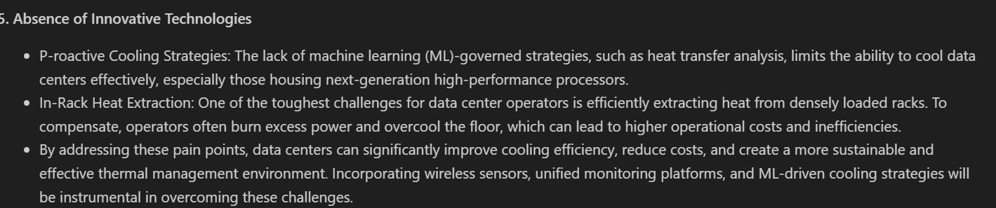

6. As data centers expand, managing space, power, and cooling becomes more challenging. Enterprises are increasingly focusing on system utilization, often finding that around 20% of ghost servers consume energy without serving any business purpose, leading to inefficiencies.

7. The Hot air re-circulation in data centers leads to hot spots, equipment overheating, and warning alarms, often prompting reactive solutions that overlook energy efficiency. Lowering intake air temperature below the threshold is typically considered sufficient, but it results in excessive cooling costs. Producing 60°F chilled air is significantly more expensive than optimizing airflow to maintain intake temperatures below 80.6°F using 77°F air, highlighting the need for improved cooling strategies to reduce energy consumption.

Data centers often experience both bypass and re-circulation airflow issues, sometimes occurring independently in different areas and sometimes overlapping. Lowering temperature set points and increasing airflow to address hot spots can unintentionally lead to cooler return air in certain areas, causing fans to circulate uncooled air. This process, known as bypass airflow, can contribute to inefficiencies and even create new hot spots, undermining cooling efforts.

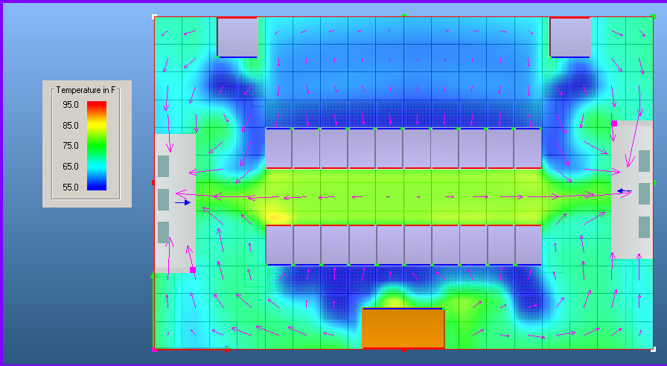

In data centers, managing airflow is complex, with bypass and re-circulation occurring simultaneously. Reactive measures like lowering temperature set points and increasing airflow may result in unintended inefficiencies, such as cooler return air recirculating without cooling, which can lead to energy waste and potential new hot spots. Proper airflow management strategies are essential to avoid such issues and optimize cooling performance.

By addressing bypass airflow and hot air re-circulation issues through measures like sealing leaks and adjusting airflow to match demand, data centers can achieve lower Power Usage Effectiveness (PUE) without relying on free cooling.

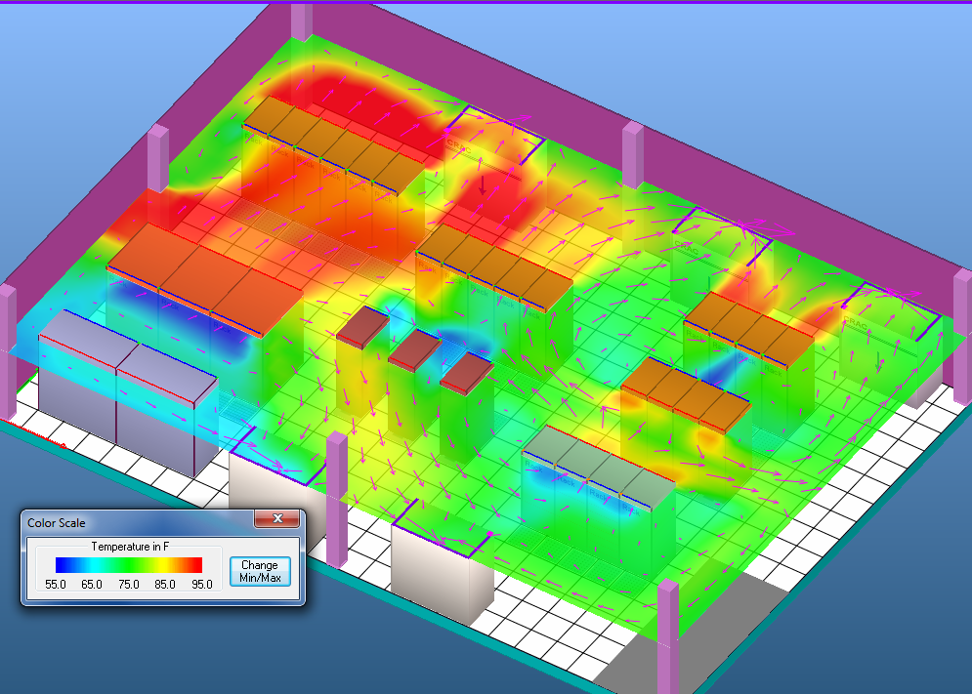

Effective environmental monitoring in data centers is crucial for equipment performance and longevity. Insufficient cooling can cause overheating, while excessive cooling leads to unnecessary costs. Data Center Infrastructure Management (DCIM) tools help optimize conditions by monitoring and measuring key environmental factors.

5. DCEWS **Heat spot organization Visualization Features enables to ;**

* 1. **) Customizable Data Overlays:**
  + Allow users to overlay additional metrics such as power consumption, airflow efficiency, and rack density onto the heatmap for a more comprehensive analysis.
  1. **Real-Time Alerts and Threshold Indicators:**
  + Incorporate dynamic alerts that highlight critical temperature thresholds, enabling proactive responses to potential issues.
  1. **Predictive Analytics Integration:**
  + Use AI-driven insights to forecast potential overheating risks based on historical trends, seasonal variations, and equipment usage patterns.
  1. **Drill-Down Capabilities:**
  + Enable users to zoom into specific areas of the facility, down to individual racks or equipment, for granular insights and targeted troubleshooting.
  1. **Customizable Reporting Dashboards:**
  + Provide tailored reports that can be exported and shared with stakeholders, summarizing trends and recommendations based on heatmap analysis.
  1. **Multi-Facility Comparison:**
  + Allow data center owners to compare heatmaps across multiple locations to benchmark performance and identify optimization opportunities.
  1. **Integration with IoT Sensors:**
  + Connect with IoT-enabled sensors to collect real-time data from critical equipment and dynamically update the heatmap for continuous monitoring.
  1. **Historical Trend Analysis:**
  + Offer time-lapse heatmaps to analyze temperature trends over days, weeks, or months, helping with capacity planning and energy efficiency improvements.
  1. **User-Friendly Mobile Access:**
  + Mobile-friendly version of the heatmap visualization, allowing facility managers to monitor conditions from anywhere.
  1. **Interactive Collaboration Tools:**
* Provide annotation and collaboration features, enabling teams to mark areas of concern and share insights in real time across departments.

By implementing these features, data center operators can maximize operational efficiency, improve cooling strategies, and extend the lifespan of critical equipment.